**Project: Network Research**

**Author: Abioye Oyatoye**

**Trainer: ThinkCyber**

**Screenshot of the program running correctly**

1. Running the script from CLI

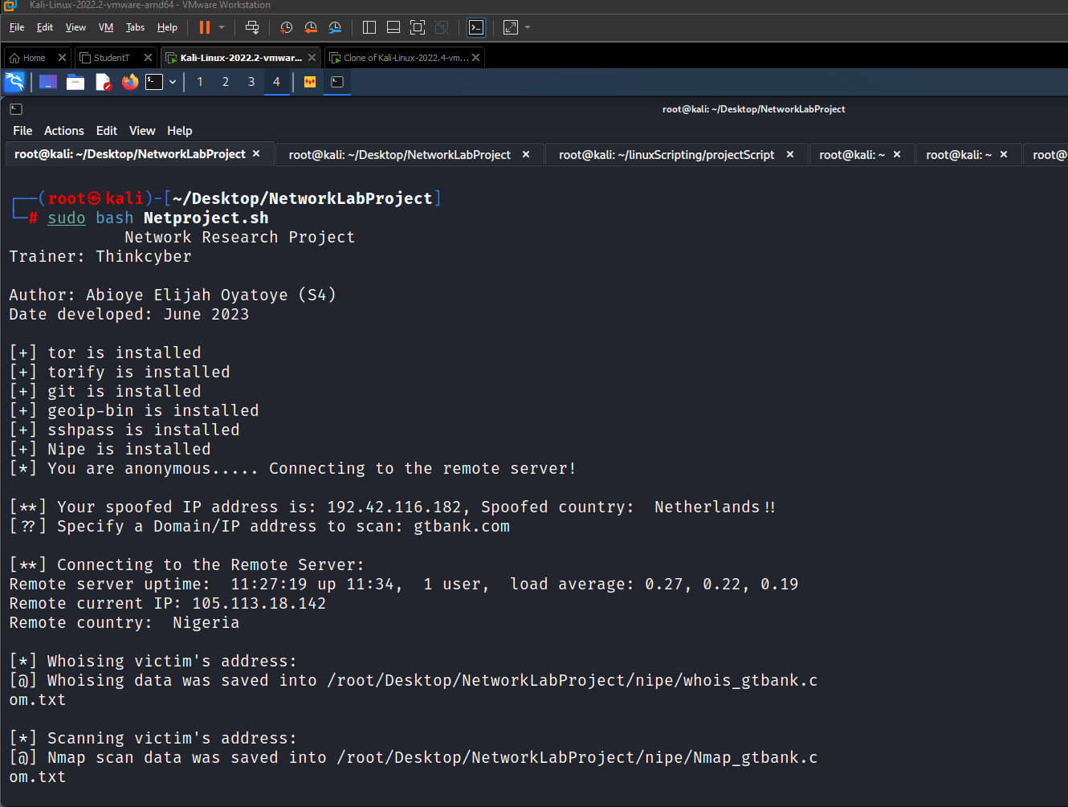

1. Opening the created log **Netresearch.log**

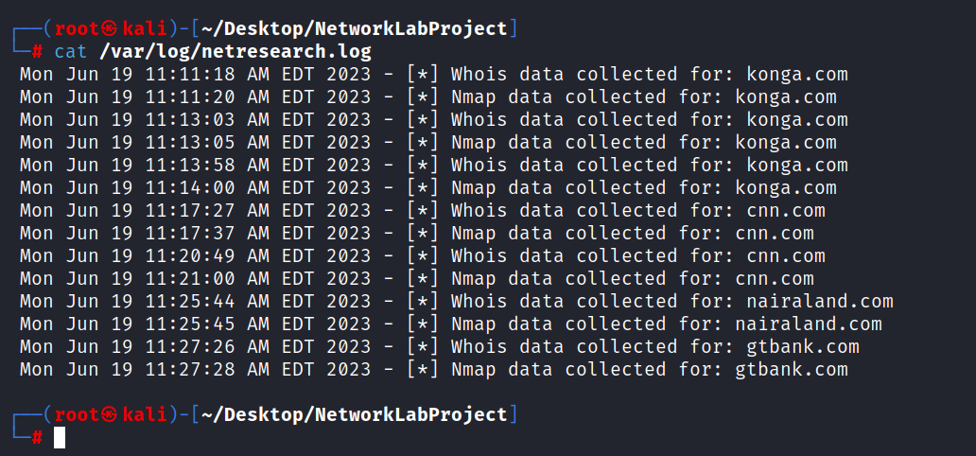

1. Opening the **whois** and **nmap** for **gtbank.com**



